Add New Product (Styles)
      - Go to e-Store/Styles
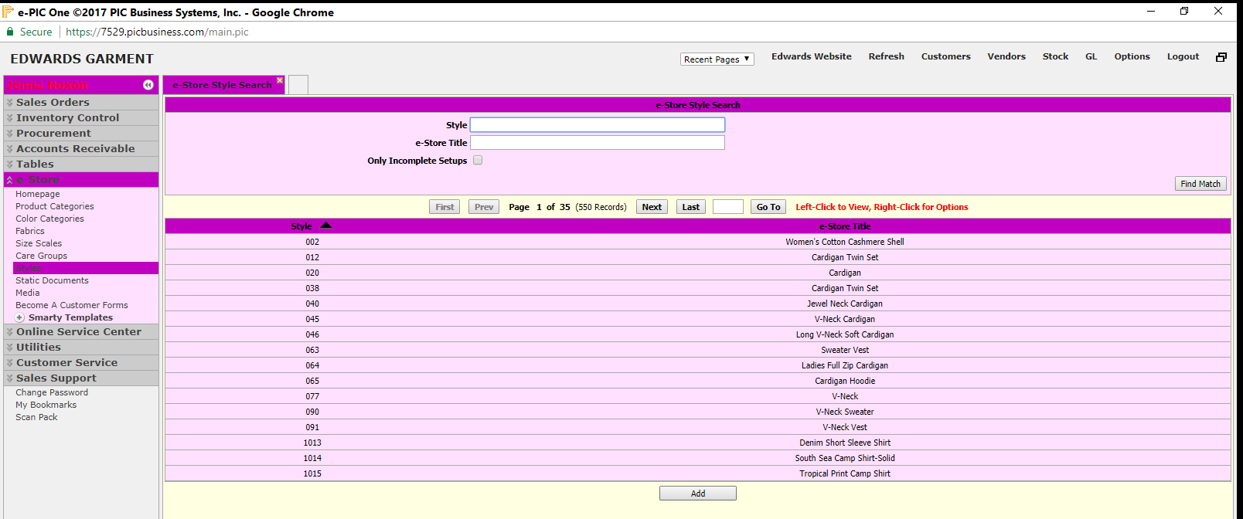

      - Enter product number in and hit enter or ‘Find Match’ (for first time product usually does not show up, but it may)
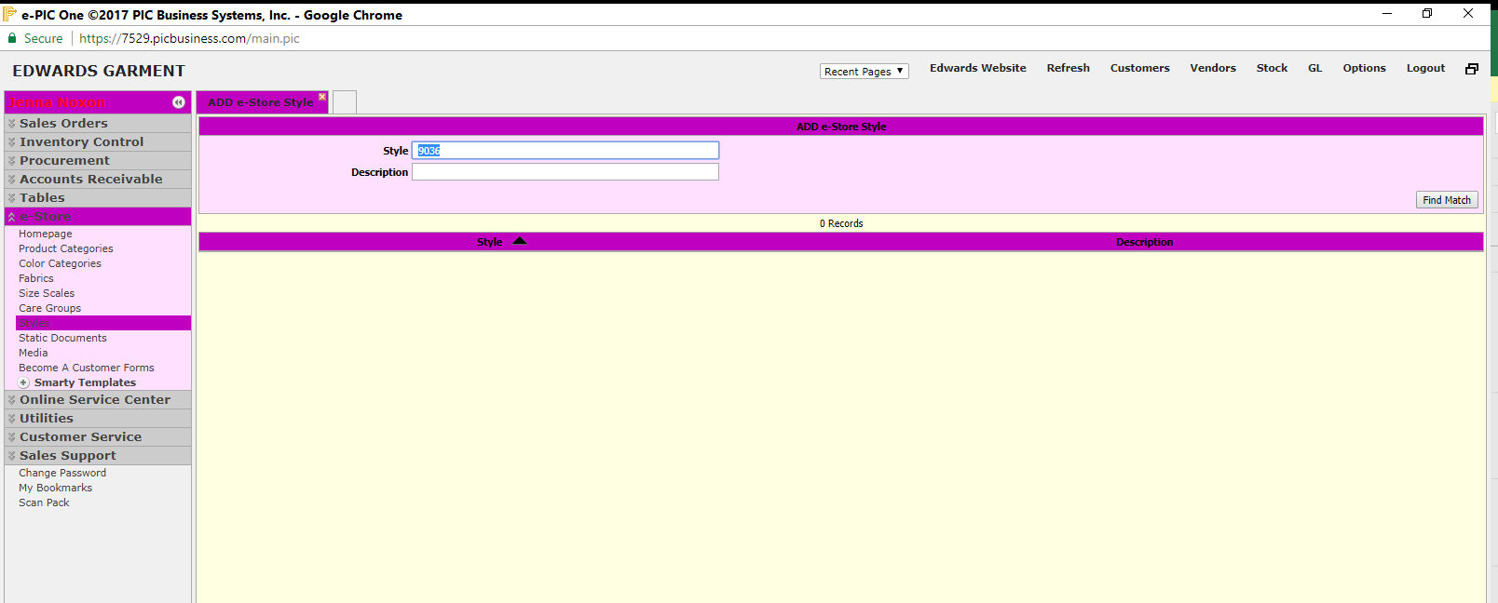

      - Click the ‘Add’ button

      - Enter product number and hit enter or ‘Find Match’ (style should show now)
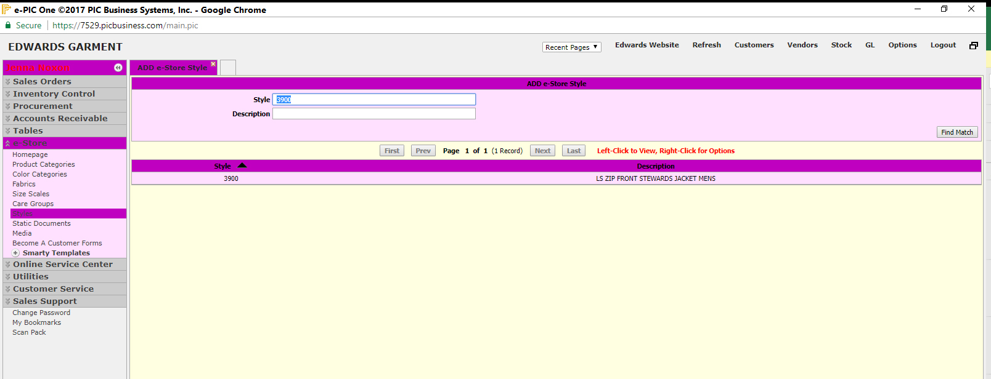

Enrich New Product (Styles)
      - Click the product in the list (The first time in, you don’t get right click/left click choices, you may only change)

      - Categories 1st tab. Place a check mark in the correct category/sub category for the product
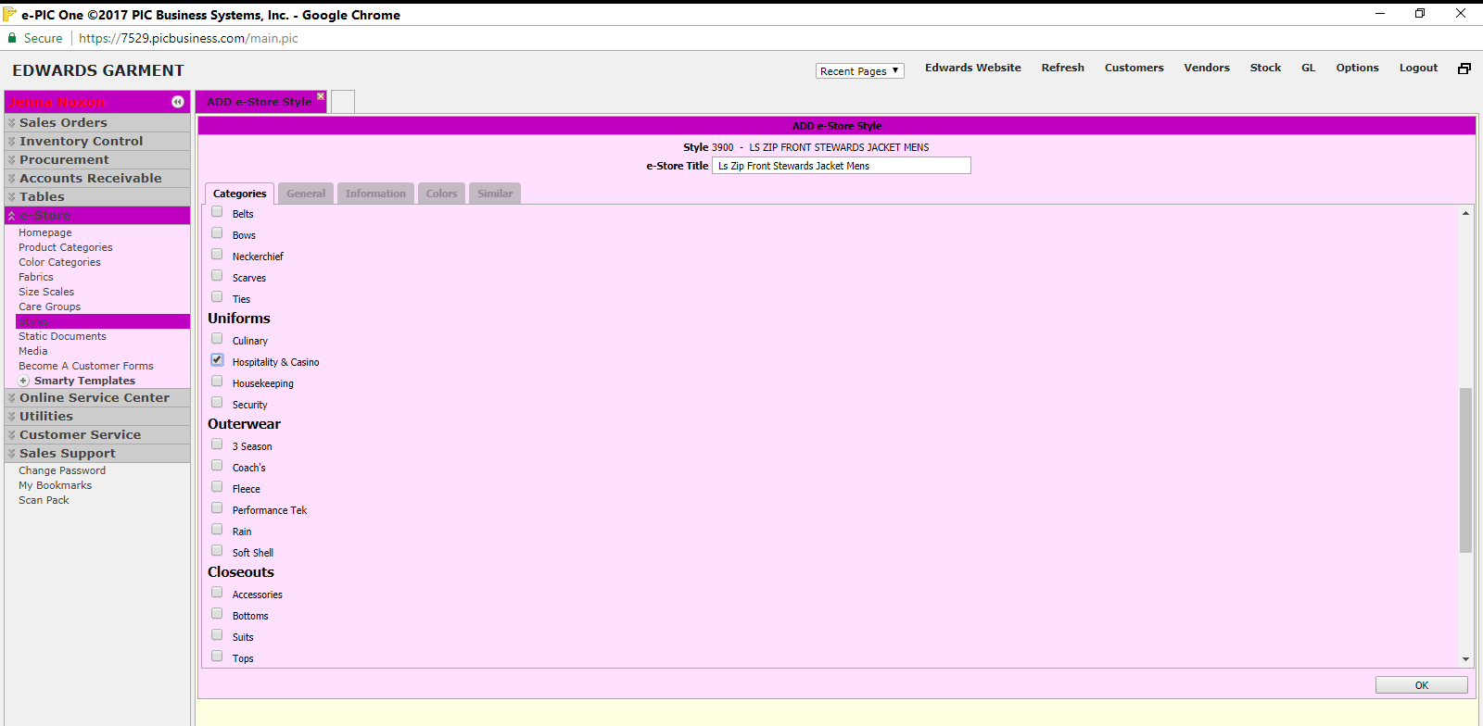

      - Click 2nd tab (General) enter/choose the care group, size scale, fabric blend, sell and spec sheets
(all info: S:/Product Development/TRI-LINGUAL CARE LABELS.xls)
      - Upload the sell sheet and spec sheet (info: I:/Product Specs/Sell Sheets (and) Spec Sheets)
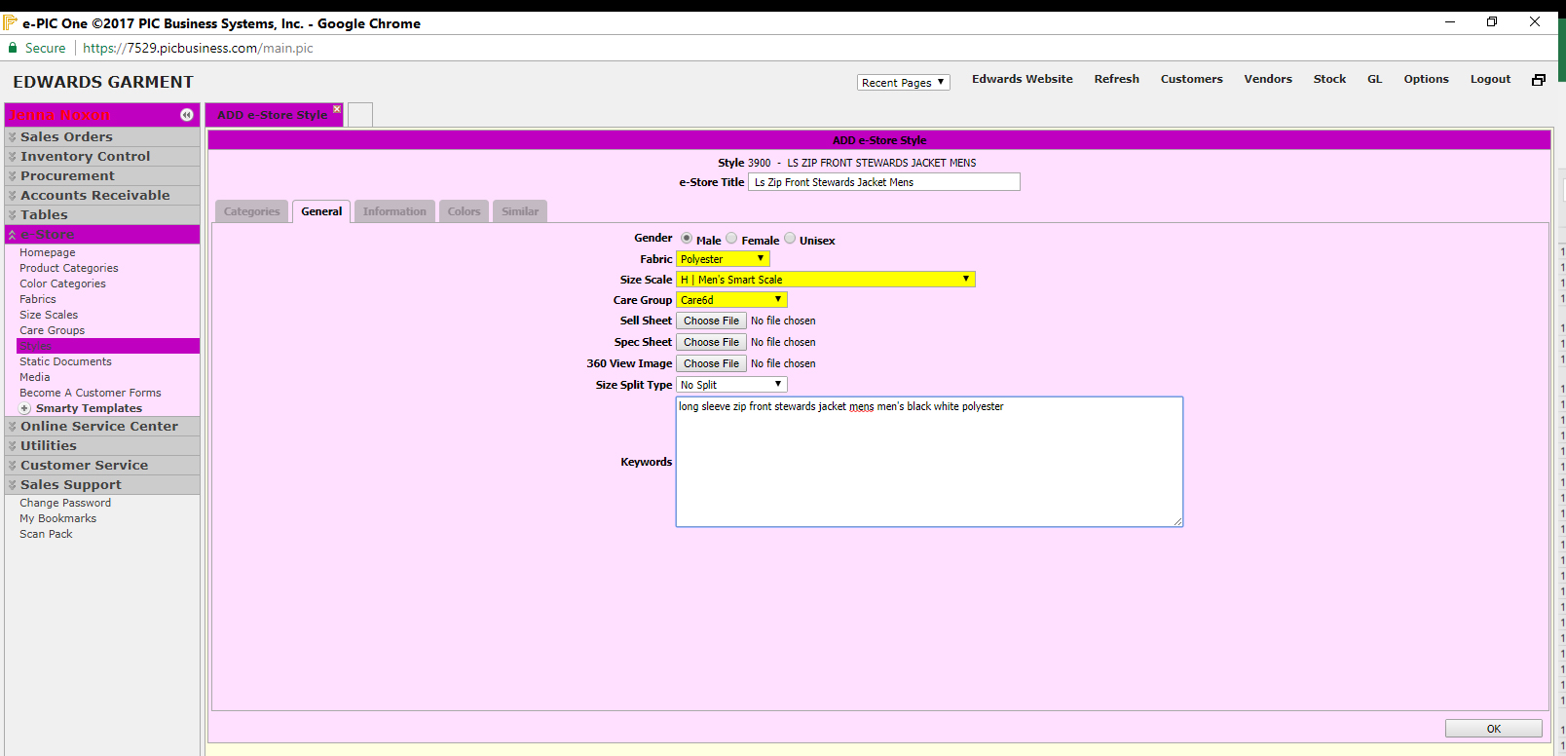

      - Click 3rd tab (Information) enter the ‘pretty words here’ (flowery product blurb) and the html selling points (info: catalog – get this from Bryan)
      - Enter the 1st sentence of ‘pretty words here’ and the # of colors, the blend, care and companion in html format for the ‘quick view’ and the ‘compare’ features
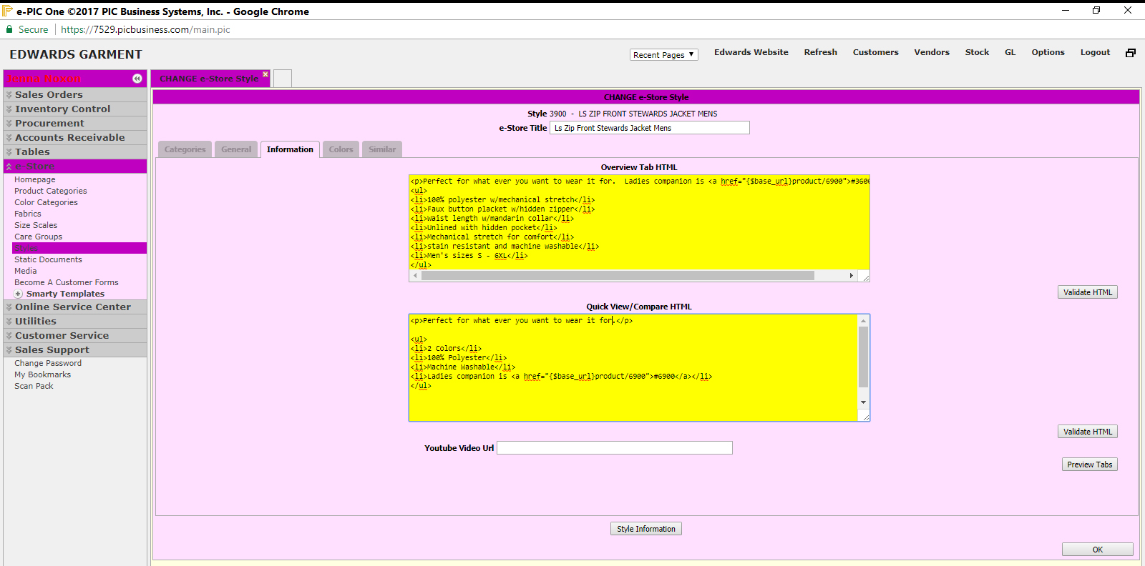

      - Click the 4th tab (Colors)
      - Set the color groups for each color
      - Upload the swatch and image files (info: I:/New Website Folder/Color Swatches) and (:/New Website Folder/Images)
      - Choose a default image (never choose an image marked ‘sale’ or ‘discontinued’ unless the entire styles has been discontinued or placed on sale as the price will incorrectly show in the millions of dollars)
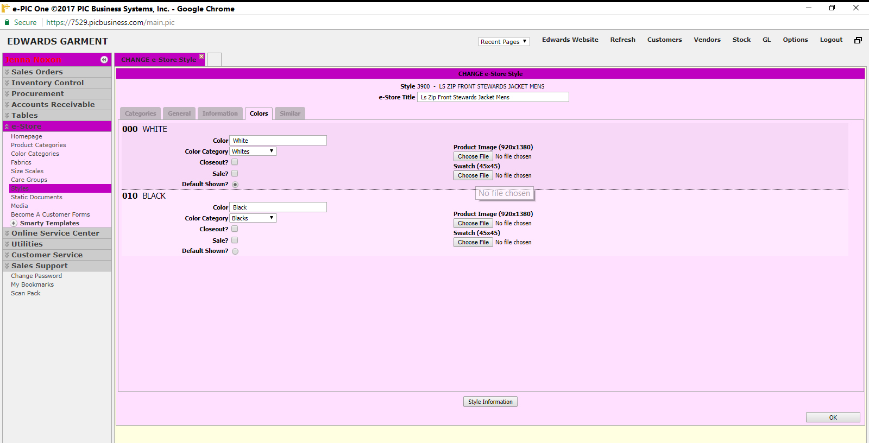

      - Click the 5th and last tab (Similar)
      - Enter style numbers of similar or complimentary products
      - Click ‘OK’ to save

Edit Existing Product (Styles)
      - Right click on product number and choose ‘change’
      - Change to Sale
      - Click 1st tab (Categories)
        - Change to Sale ~ Entire style
              - Place check mark in the appropriate sale category
        - Sale on Certain Colors
              - Go to tab 4 (colors)
              - Click the sale radio button on each sale color
        - Click ‘OK’ to save

      - Change to Discontinued
      - Click 1st tab (Categories)
        - Change to Discontinued ~ Entire style
              - Place check mark in the appropriate sale category
        - Certain Colors
              - Go to tab 4 (colors)
              - Click the discontinue radio button on each sale color
        - Click ‘OK’ to save

Add Product Categories
      - Click ‘add’
      - Assign a sequence (the bigger the number the lower in the list it will appear)
      - Assign a title for the category
      - Click ‘OK’ to save
Edit Product Categories
      - Right click on the category choose: ‘Change’
      - Change the sequence number or the title
      - Click ‘OK’ to save
Add/Edit Sub Categories
      - Right click on the category and choose: Define Sub Categories
      - To Add: Click the ‘Add’ button and enter title of the sub category
      - To Edit: Right click on the category and choose ‘Change’
      - Change the title info
      - Click ‘OK’ to save
Add Color Categories
      - Click ‘add’
      - Assign a sequence (the bigger the number the lower in the list it will appear)
      - Assign a title for the category
      - Click ‘OK’ to save
Edit Color Categories
      - Right click on the category choose: Change
      - Change the sequence number or the title
      - Enter color hex number if known
      - Click ‘Multi-Color’ if it’s a multi-color category (plaids, checks, island etc.)
      - Click ‘OK’ to save
Add Fabric Categories
      - Click Add
      - Enter sequence number (the bigger the number the lower in the list it will appear)
      - Enter Title
      - Click ‘OK’ to save
Add Size Scales
      - Click Add
      - Enter Size Scale Title
      - Click ‘choose file’ button and browse to the size scales (info: I:/2017 Size Scales)
      - Click ‘Open’ to upload
      - Click ‘OK’ to save

Edit Size Scales
      - Right click on size scale to be edited, choose ‘Change’
      - Enter Size Scale Title
      - Change the size scale name
      - Upload new scale: click ‘Choose File’ button and browse to the size scales (info: I:/2017 Size Scales)
      - Click ‘Open’ to upload
      - Click ‘OK’ to save
Add Care Groups
      - Click Add
      - Enter Care Group Title
      - Type/copy paste each line of care instructions from TRI-LINGUAL CARE file (S:/Product Development/TRI-LINGUAL CARE LABELS.xls) to each line for the group
      - Click green ‘+’ button to add another line
      - Click ‘OK’ to save
Edit Care Groups
      - Right click on group and choose ‘Change’
      - Change Care Group Title
      - Type/copy paste each line of care instructions from TRI-LINGUAL CARE file (S:/Product Development/TRI-LINGUAL CARE LABELS.xls) to each line for the group
      - Click green ‘+’ button to add another line
      - Click ‘OK’ to save

Product File
      - Submit list of new/discontinued products to John Olsen
      - Make sure he got the new and discontinued styles files
      - Submit list of ‘out of the norm’ swatches (if any) to John for association with new products
      - Review Product file for new products/discontinued (click the images links to make sure correct image shows)
      - Use Product file for Search engines and customer requests

Search Engines
      - Determine if search engine uses a specific file format and fill it in or request IT create
      - Submit Product/Site-specific File to appropriate search engines
      - Zip (if necessary) and submit images/swatches to search engines
      - Submit digital catalog if required
      - Submit list of changes (adds/deletes/changes) for reference
      - Review/Verify products after notification that they are posted

